Risk Intelligence & Control – Tamil nadu

Post Delivery Asset Verification – Tractor Loan

Date of visit: 17.09.2026

Location : DINDIGUL
Name of the borrower : VEERAMANIKANDAN S
Address : DOOR NO 2/262 - KOLLAPATTI DINDIGUL - ODDANCHATRAM TK - DINDIGUL DIST – 624619
PHONE : 8610535072
Agg no : 803645423
Date of vehicle delivery taken : NA

Product:
Availability & condition of asset : NA
Loan Amount disbursed (Rs) : NA
Date of disbursement : NA
Model & Year of manufacture : MAHINDRA TRACTORS - MAHINDRA 575 BPE
Hypothecation : NA
Documents Possessed by the borrower
1) Original/ Temporary RC Book duely HYPOTHECATED to HDFC bank : YES /NO
2) Insurance : YES /NO
Details:
3) Invoice : Whether borrower has a copy of Invoice : YES /NO
Whether the invoice has been hypothecated : YES /NO
Date of Invoice : YES /NO

Registration details
Registration No :
Whether the vehicle has been registered in borrower's name : YES /NO
Whether Registration No is matching with that of RC Book : YES /NO

Engine No : ZTA3MAA4906
Chassis No: MBNAAALGATZB13338

Whether Chassis No and Engine No are matching with that of RC Book : YES /NO

Third party check:

1) Met Long distance Neighbor he confirmed that applicant is stay.
Remarks:

Resi Profile Verification:

CIC had visited the given address, Met borrower Veeramanikandan and confirmed that he is residing in the mentioned address 9 years. It is Rental Rc/sheeted house around 300 sqft approx. Family members are 03 Borrower is having 4 acres of land cultivating Onion, Beetroot, Tomato and vehicle verified and Asset model MAHINDRA TRACTORS - MAHINDRA 575 BPE matching , engine number ZTA3MAA4906 and chassis number MBNAAALGATZB13338 both are matching. Asset was own usage and it is registered Borrower is not having RC and Insurance Purchased date May 2026, Checked with neighbor and confirmed borrower is residing in this house Status: Positive.

RESI PHOTOS:

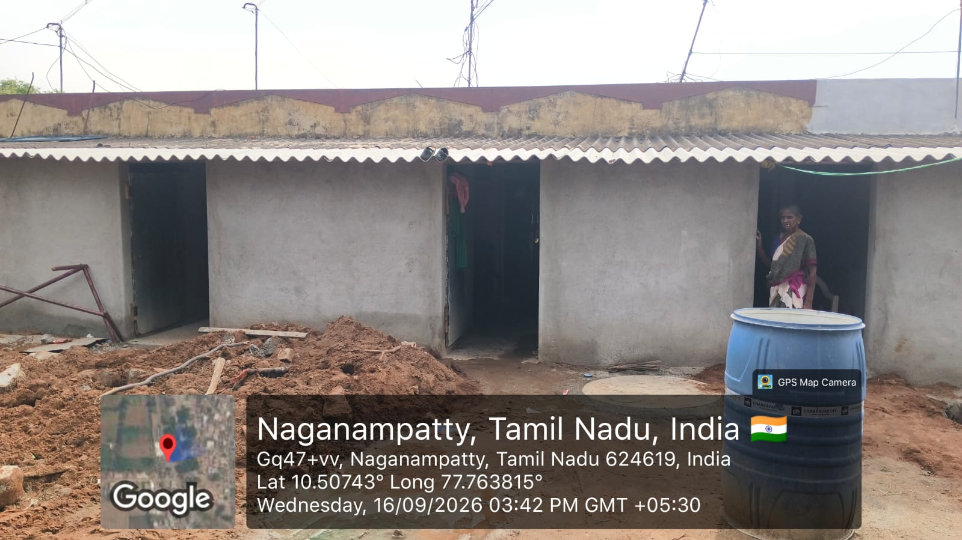

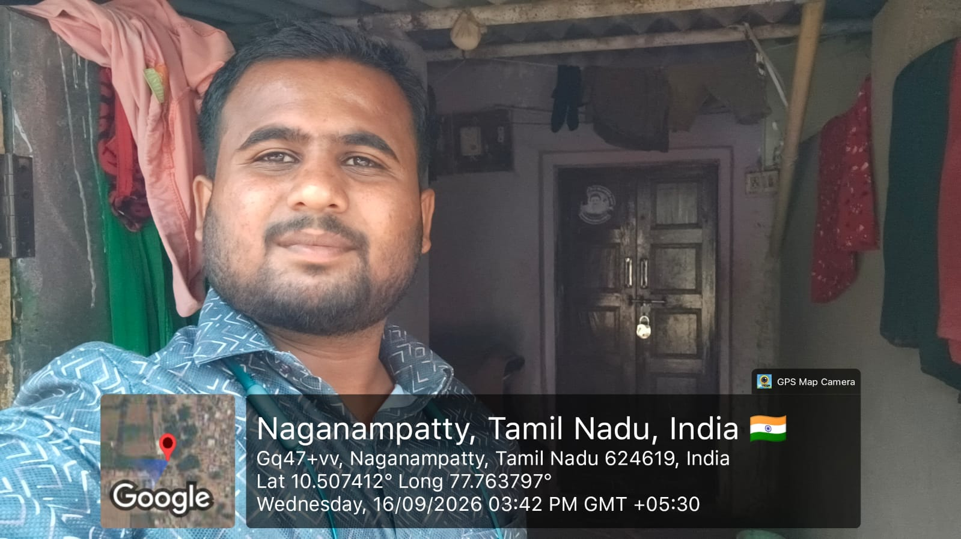
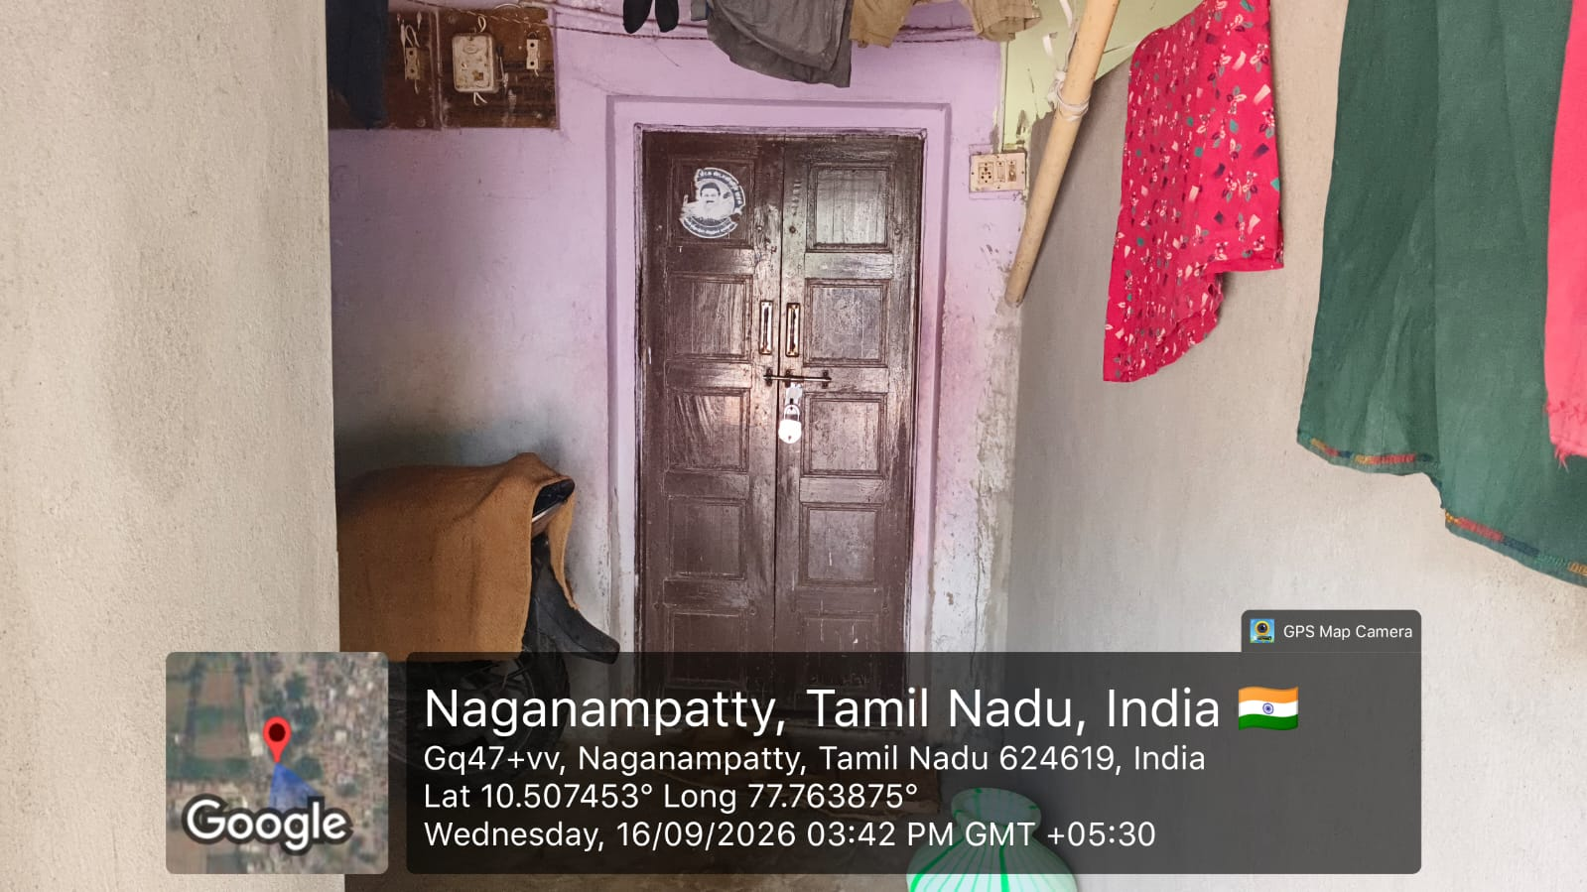

ENGINE AND CHASIS NUMBER :

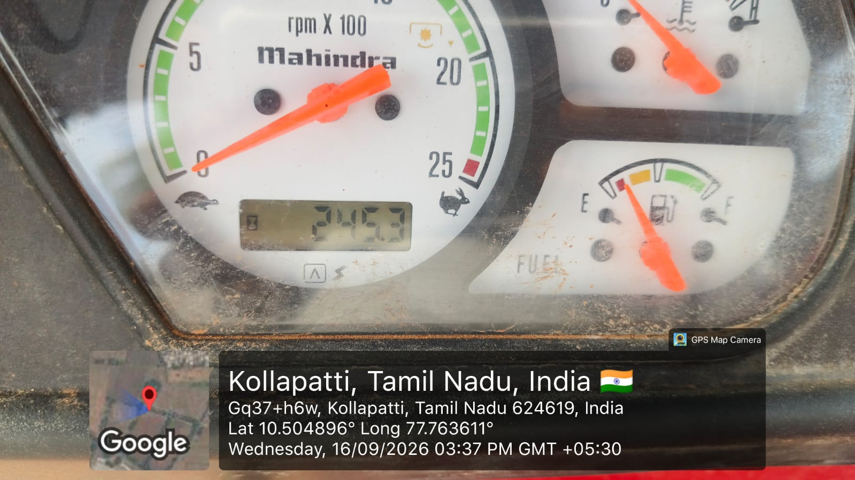
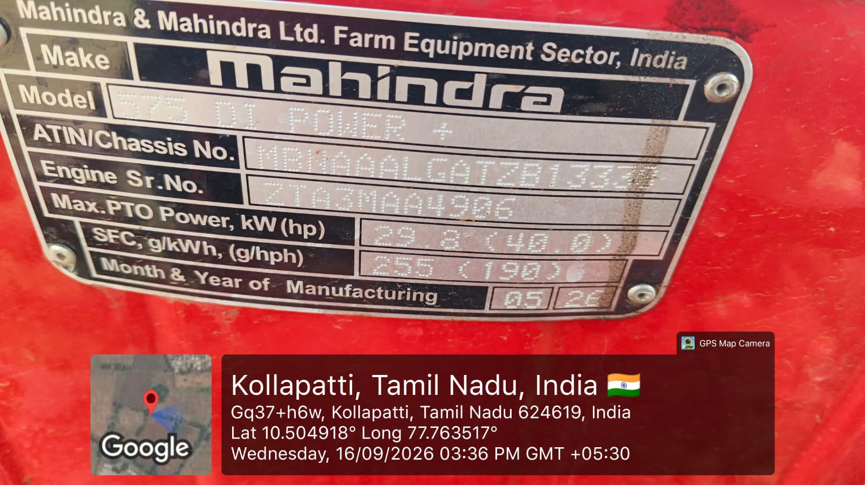

TRACTOR PHOTOS;

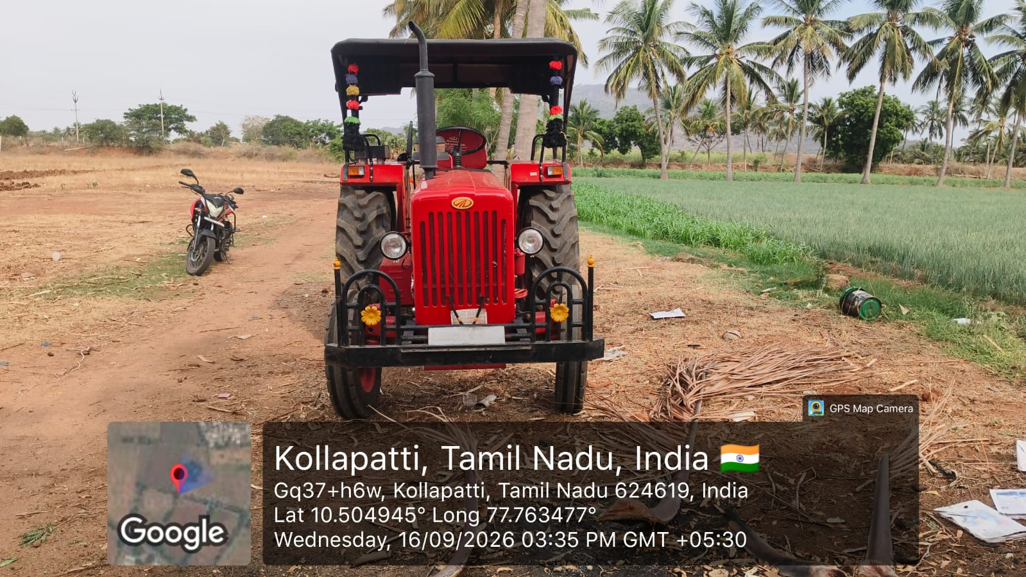
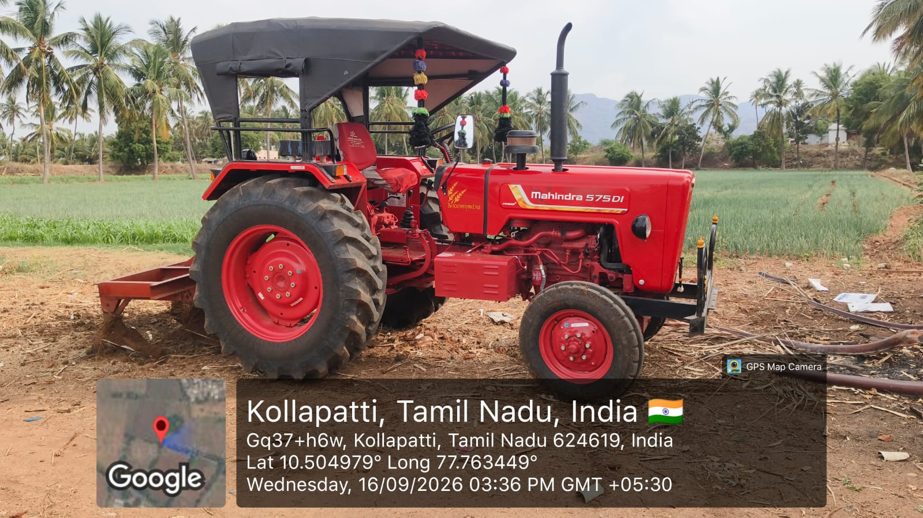
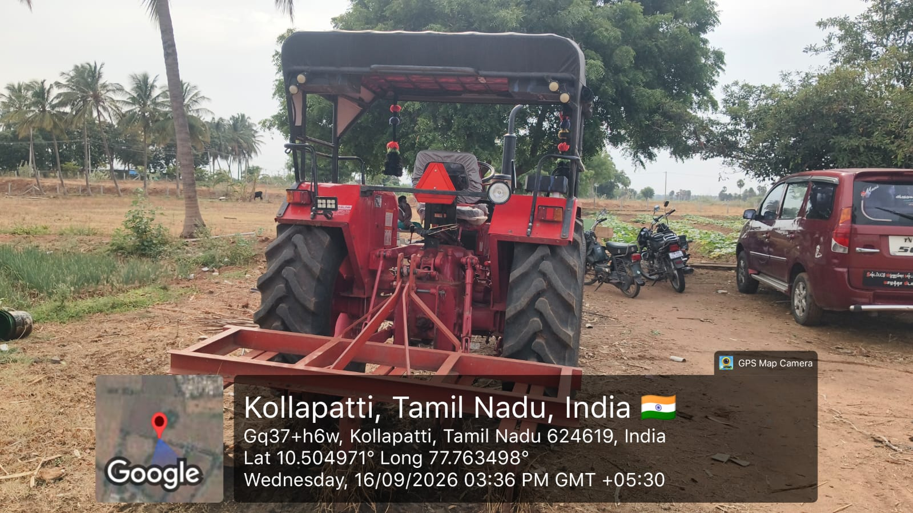
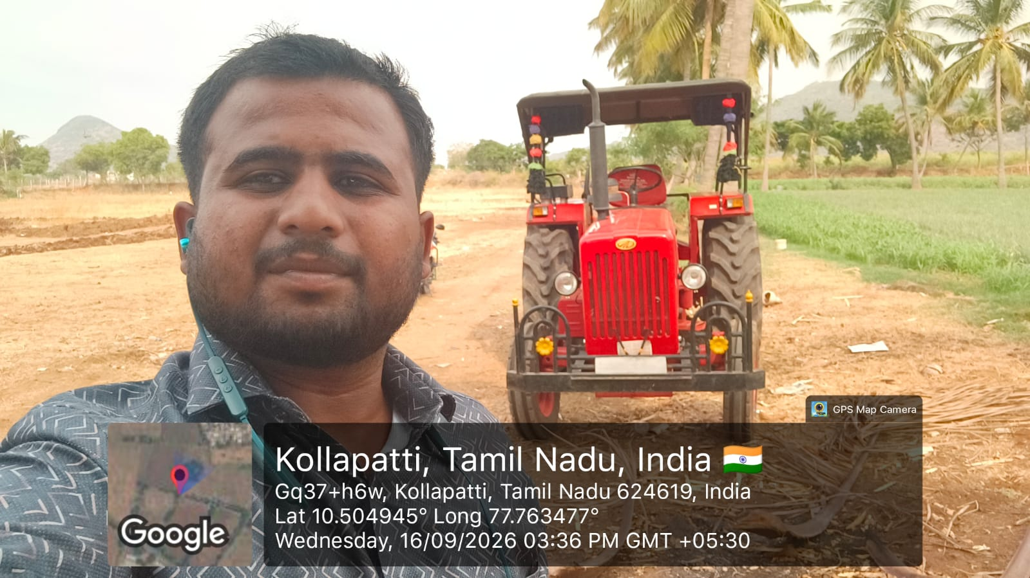
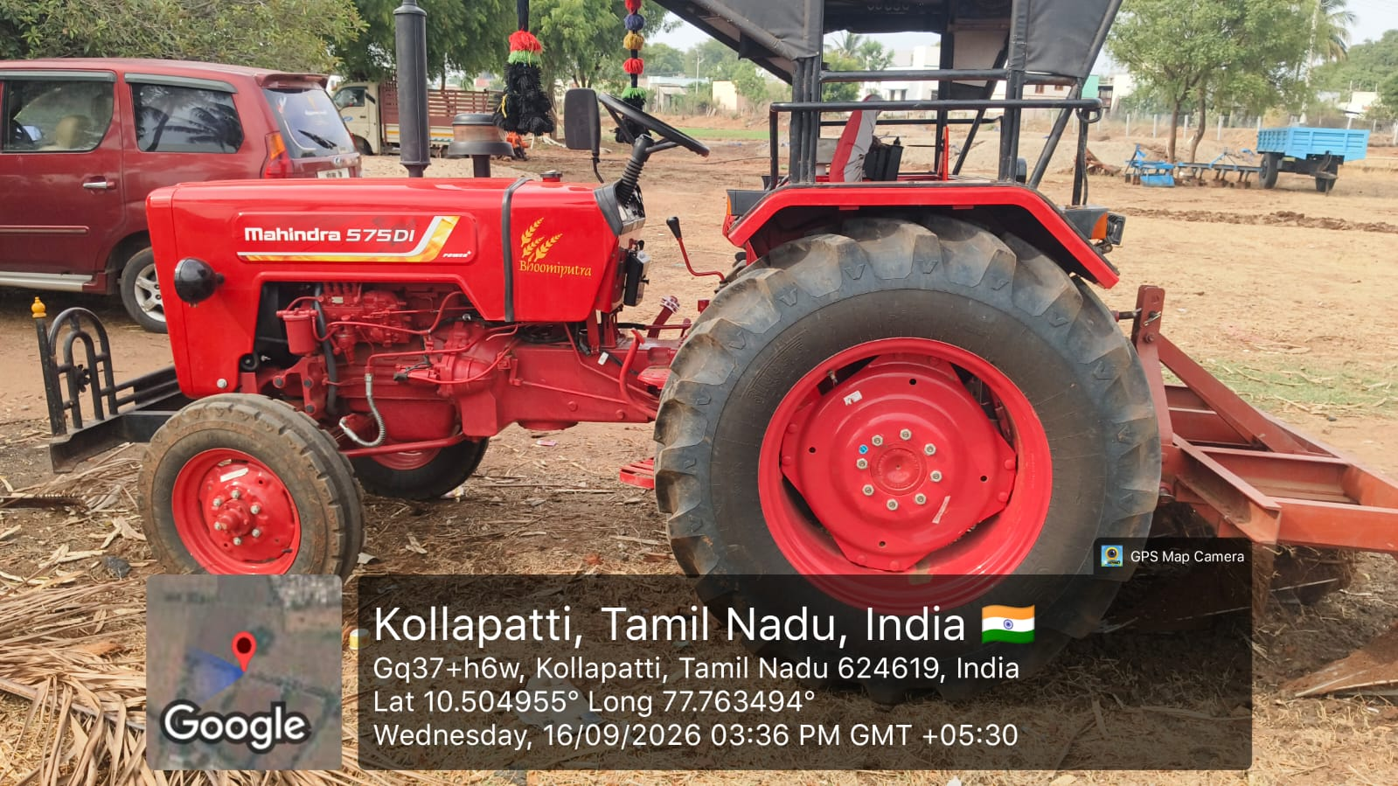

Verifier Name: Muthukumar

Signature and Seal of Agency



